Nature and biodiversity
Sustainability Report 2026 – Chapter 3 (draft)
Hannah Weber · 25 September 2026

Marine life at Harrow Bay
Pile driving is the loudest phase of an offshore wind farm. Every monopile at Harrow Bay is installed behind a double bubble curtain, which kept the median noise level at 750 m at 158 dB SEL – below the 160 dB limit. Marine mammal observers paused piling nine times when harbour porpoises were detected nearby, and piling stopped completely during the seasonal restriction period.
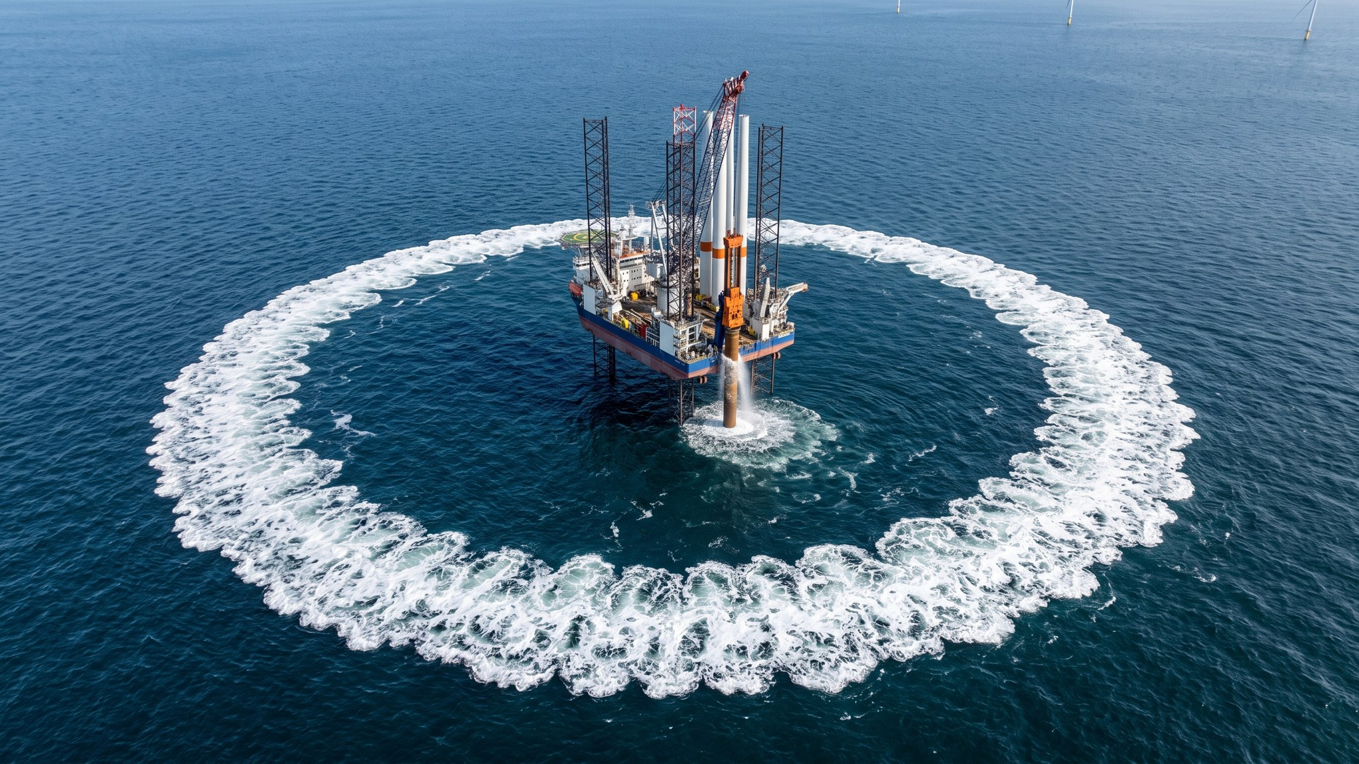
Bubble curtain around the MV Sea Atlas during piling.
Marlow Ecology flies digital aerial seabird surveys; five of eight planned surveys in 2026 have been completed. [Dr. Rachel Moss to confirm wording on gannet and kittiwake densities]

Restoring peatland at Kestrel Ridge
Since 2024 we have restored 71 ha of degraded blanket bog around the wind farm by blocking drainage ditches with 495 peat dams. Black grouse numbers at the lek have risen from 14 to 17 displaying males.
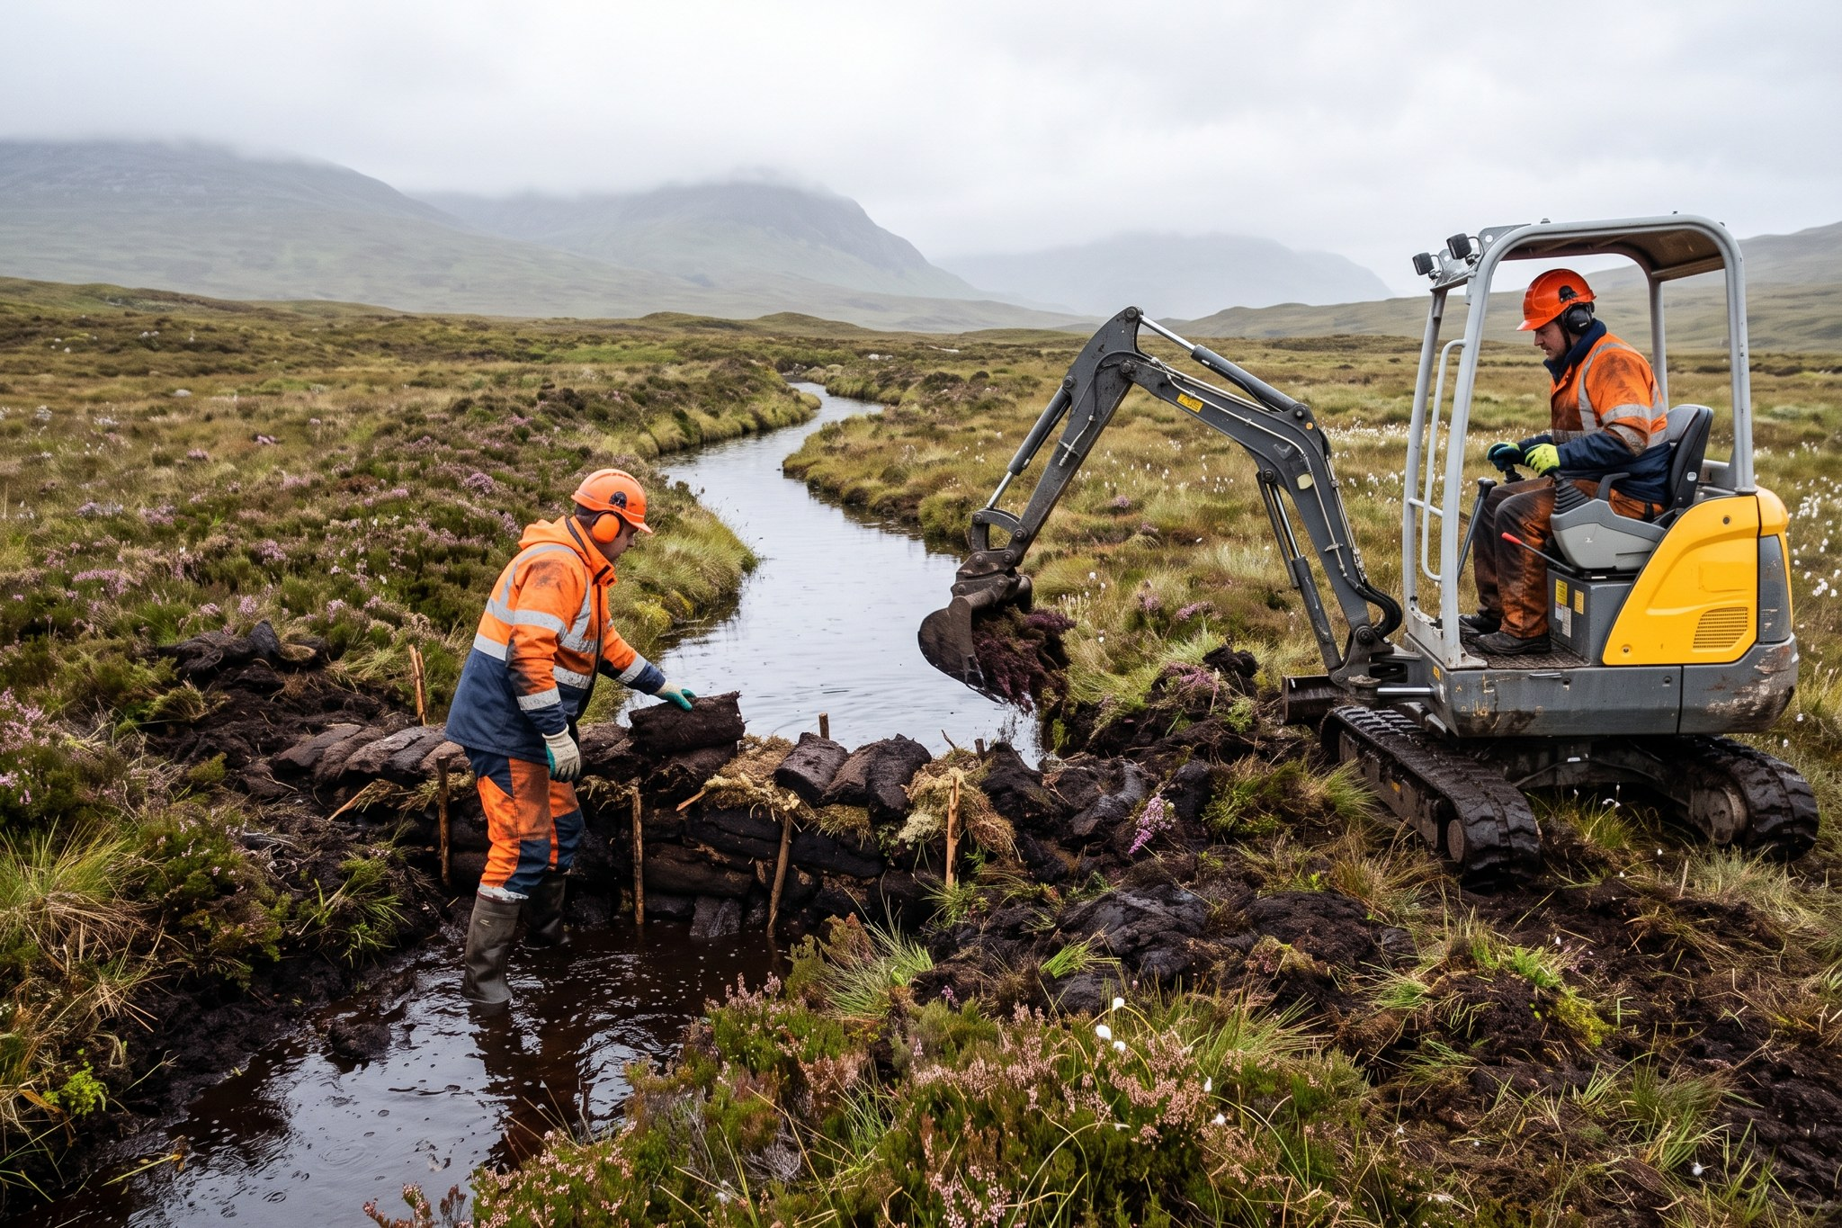
Building peat dams at Kestrel Ridge.

Millbrook – designing for nature
The Millbrook planning application (MDC/2026/0412) commits to 20 % biodiversity net gain, 24 skylark plots and 3.8 km of new hedgerow. Because the project is still in planning, we describe these as commitments, not results.

